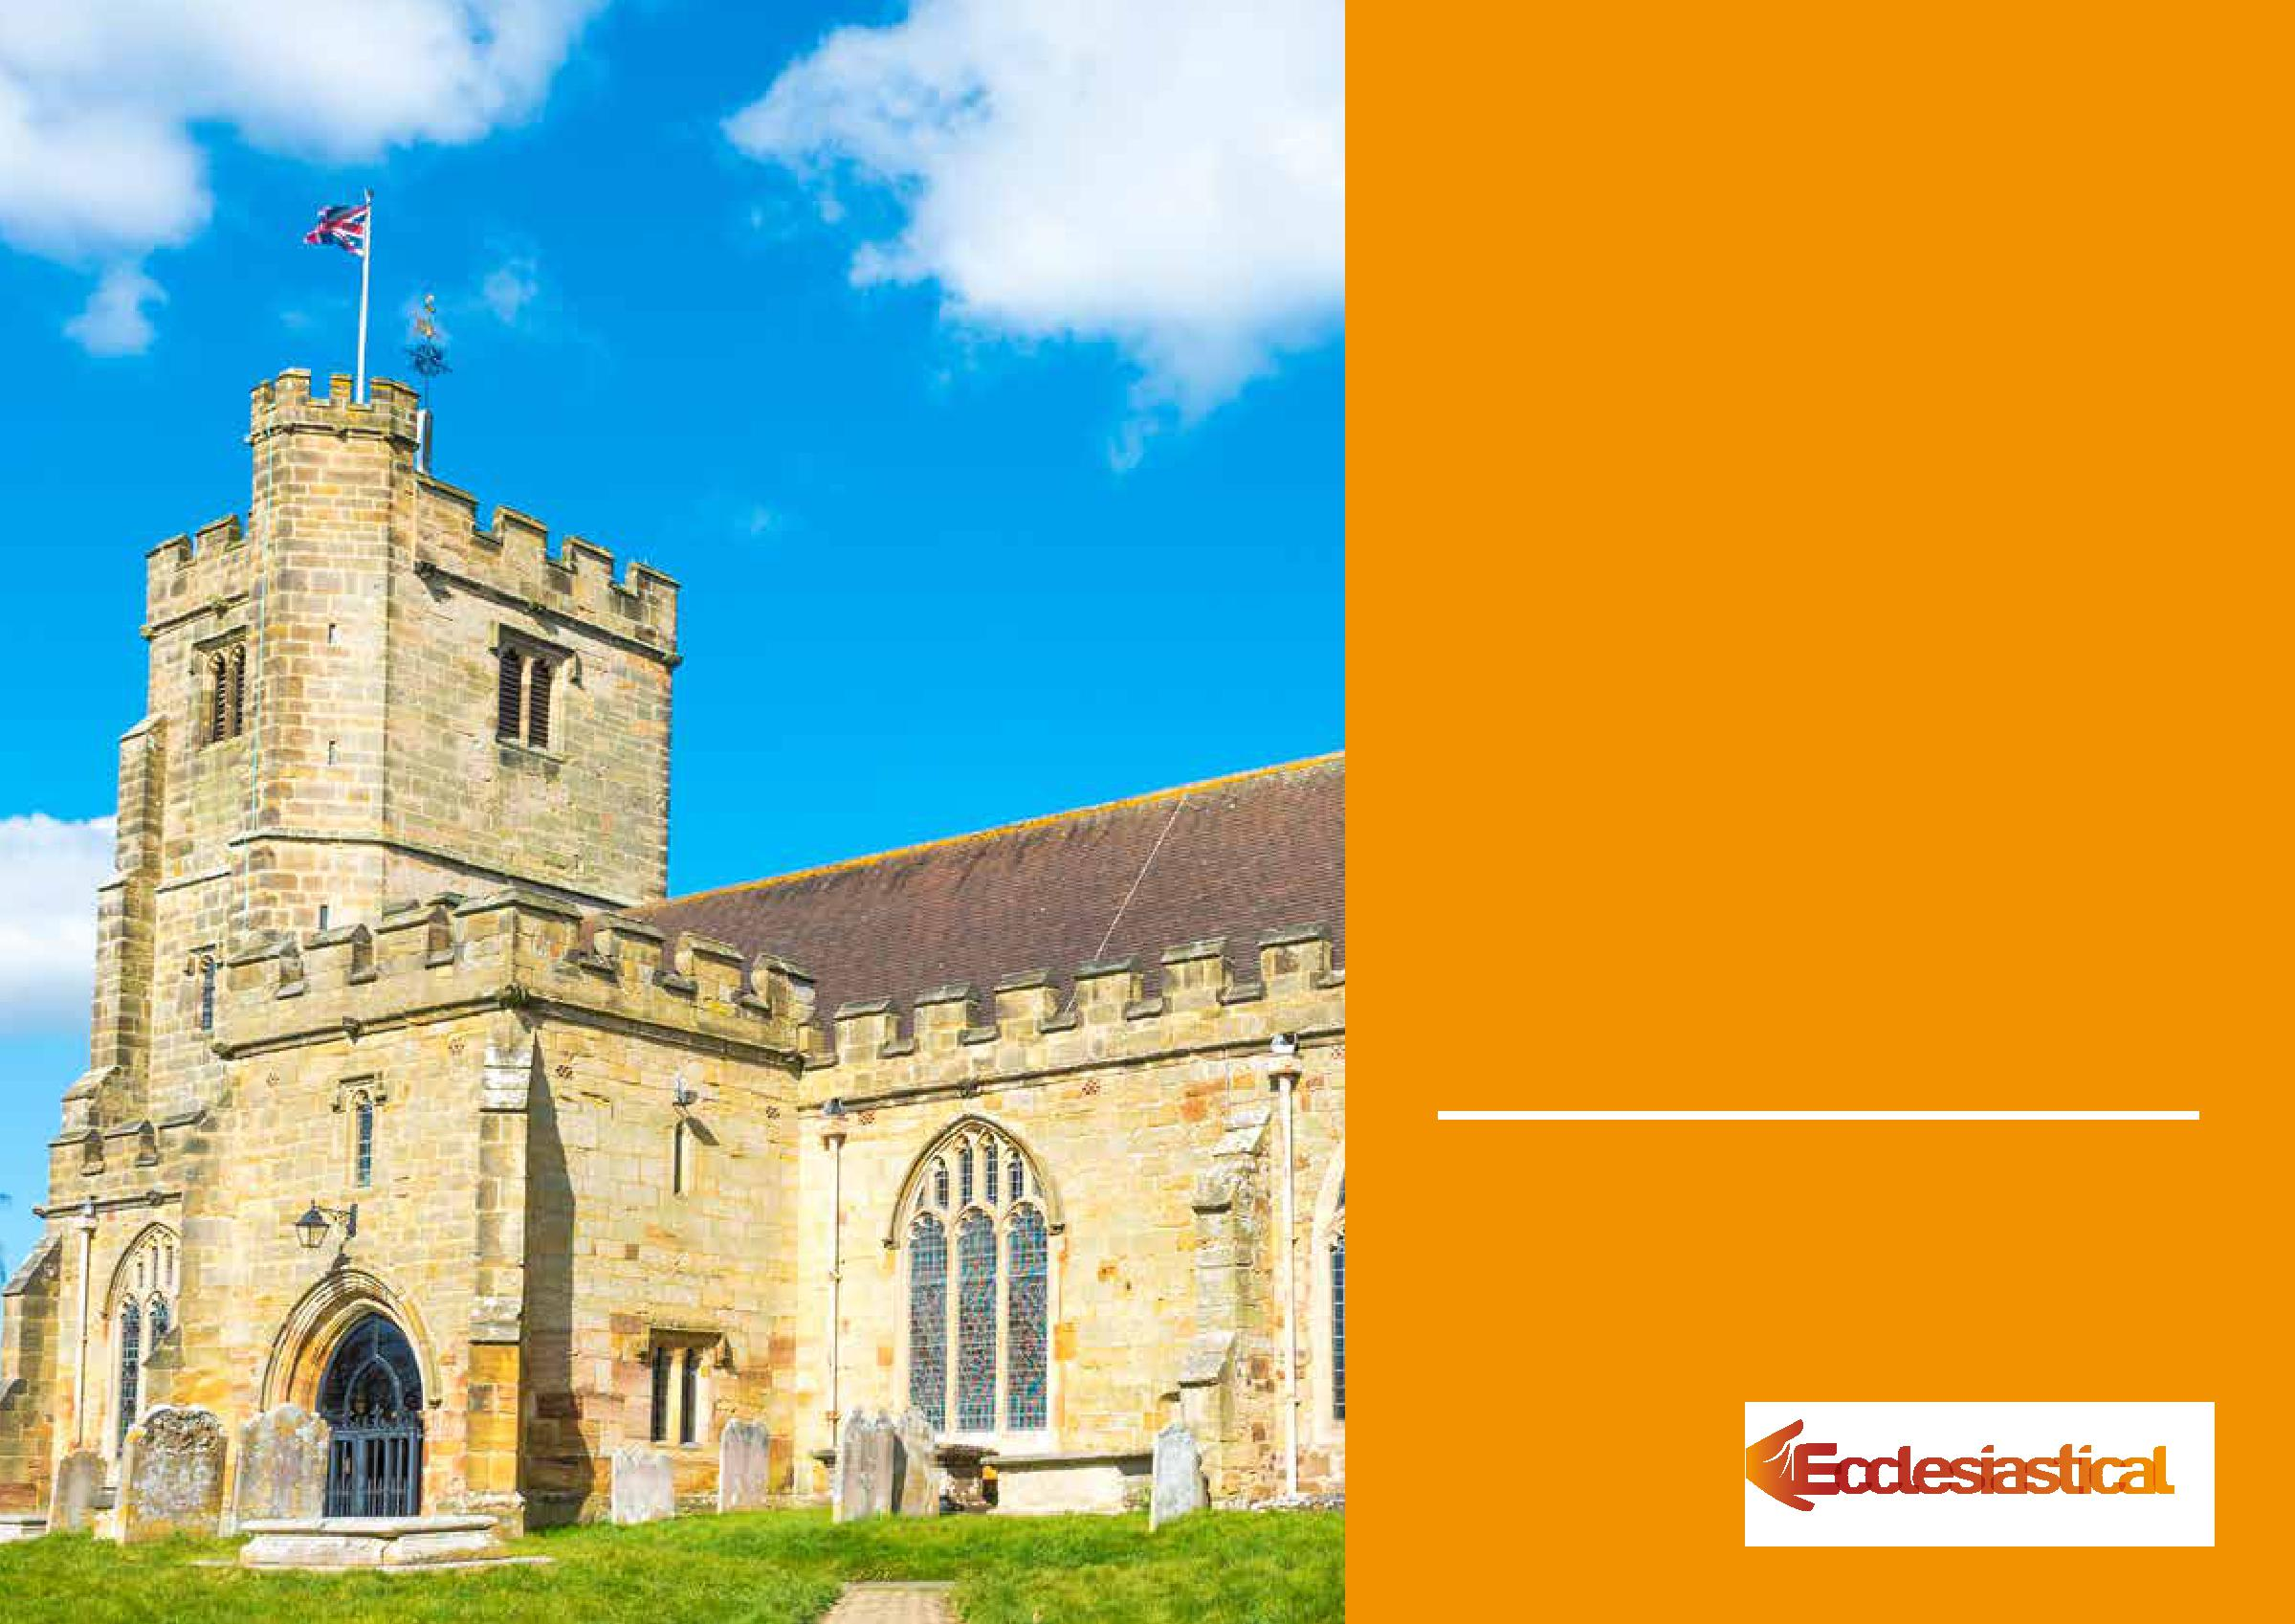

Keeping People Safe

CHURCH HEALTH & SAFETY TOOLKIT

Health and Safety Policy


Health and Safety Policy

Our Health and Safety Policy

Name of Church:

St Andrew Clewer St Agnes Spital

Address:

Mill Lane St Leonards Road
Windsor Windsor
SL4 5JH SL4 3DX

As a church we understand that we owe a duty of care to ensure the safety of those who visit or use our church, hall or churchyard.

We also know that, where we are an employer or control premises in certain circumstances, we have to meet the requirements of health and safety law.

In particular, we know that if we are an employer having five or more employees, we are required to have a written health and safety policy. As such, we have drafted this policy to meet our duty under Section 2(3) of the Health and Safety at Work etc. Act 1974.


Health and Safety Policy

General statement of policy

Our policy is to ensure, so far as is reasonably practicable, that our activities are carried out safely and do not pose a risk to the health of our employees, volunteers, congregation, visitors and others who may use the church, churchyard or any other building we are responsible for. This will be in accordance with good practice and any relevant statutory provisions where they apply.

The Parochial Church Council (PCC) accepts its overall responsibility for this. We will ensure that adequate resources are made available to achieve this objective. Any decisions we make will have due regard for it.

We will appoint a Sub-Committee of the PCC to have specific responsibility for this policy and its implementation. We will keep health and safety matters under review at appropriate intervals. We will monitor the effectiveness of the policy, amending it where we believe it is no longer valid.

It is the duty of each employee and volunteer to exercise personal responsibility for their own safety and that of others. This policy will be brought to their attention. We will try to ensure that everyone involved with the church plays his or her part in its implementation.

Further detail about our organisation and arrangements for managing health and safety is set out in this document. A copy of it will be kept in the church and made available to others on request.

Signed*:

*on behalf of the Parochial Church Council as agreed at a meeting on:

Date:

--/--/----


Health and Safety Policy

Organisation and Responsibilities

1. The Sub-Committee of the PCC with overall responsibility for implementing our policy is:

Buildings and Churchyards Sub-Committee

They will ensure that:

- The standards set out in this policy are implemented and maintained

- Where necessary, specialist health and safety assistance is obtained

- Any hazards reported to them are rectified immediately

- Only competent persons carry out repairs, modifications, inspections and tests

- Any accidents are investigated, recorded and reported if necessary

- Relevant health and safety documents and records are retained

- They keep up to date on health and safety matters relevant to the church

- Set a personal example on matters of health and safety.

- The Churchwardens have day-to-day responsibility for implementing our policy. They are:

Heather Allbless

They will ensure that:

- All employees and volunteers are aware of their health and safety responsibilities

- Adequate precautions are taken as set out in this policy and related risk assessments

- Adequate information and training is provided for those that need it

- Any hazards or complaints are investigated and dealt with as soon as possible

Rob Taylor

- Where defects cannot be corrected immediately, interim steps are taken to prevent danger

- All accidents are reported in-line with the requirements of this policy

- Advice is sought where clarification is necessary on the implementation of this policy

- Set a personal example on matters of health and safety.


Health and Safety Policy

- All employees and volunteers have a responsibility to cooperate in the implementation of this policy and to take reasonable care of themselves and others while on church business or premises.

They will ensure that they:

- Read this policy and understand what is required of them

- Complete their work taking any necessary precautions to protect themselves and others

- Comply with any safety rules, operating instructions and other working procedures

- Report any hazard, defect or damage, so that this might be dealt with

- Warn any new employees or volunteers of known hazards

- Attend any training required to enable them to carry out their duties safely

- Do not undertake any repair or modification unless they are competent to do so

- Report any accident

- Do not misuse anything provided in the interests of health and safety.

Health and Safety Policy

Arrangements

This section sets out our general arrangements for managing health and safety and dealing with specific risks. We have removed any points that do not apply to our activities.

General Arrangements

Competent Assistance

Where necessary, we will appoint someone who is competent to assist us in meeting our health and safety obligations. Where an appointment is made, we will record the details here.

Our person appointed to assist us is: No appointment made – considered unnecessary

Risk Assessment

We will complete risk assessments to identify what we need to do to comply with health and safety law. We will record our findings, implementing any necessary precautions. We will review and revise these where we suspect that they are no longer valid.

Information and Training

We will provide any necessary information and training for our employees and volunteers in a timely manner. We will keep a record of what is provided.
We will also give relevant information to contractors and self-employed people who may need this to complete their work safely.

First Aid

We will provide adequate first aid facilities including – as a minimum – a suitably stocked first aid box and a person who will take charge of the first aid arrangements. We will also provide relevant information for employees and volunteers.

Our first aid boxes are located in: Coffee Corner, Bell Tower, St Agnes Kitchen, St Agnes Church

Our person in charge of first aid arrangements is:

Health and Safety Policy

Accident Reporting

We will keep an accident book and record details therein. We will report to the enforcing authority and keep records of certain accidents to employees, volunteers and members of the public in accordance with the Reporting of Injuries, Diseases and Dangerous Occurrences Regulations.

Our Accident Books are kept in: St Andrews Vestry, St Agnes Church back passage

Monitoring

We will make periodic checks to ensure that our precautions remain effective and adequate. We will also ensure that any lifting, work or electrical equipment and church utilities are inspected as necessary to ensure that they remain safe. We will keep records of the checks we make.

Contractors

If we employ contractors, we make sure that they have their own health & safety policy and public and Employers Liability Insurance by asking to see copies of the relevant documents.

Record Keeping

Our Health and Safety Risk Assessments, records and other documents are kept in: Church Office and Vital Buildings Management System


Health and Safety Policy

Specific Arrangements

Asbestos

We will take steps to identify the presence of asbestos in our buildings and, if so, assess any risk from it. We will then implement any plan to manage that risk. We will also provide relevant information to others who might need it (for example, building contractors). We will keep records of the checks, assessments and plans we have made.

Bell Ringing

We will ensure that adequate precautions are in place to protect bellringers and others who may enter the ringing room and bell chamber. This will include any emergency evacuation procedure, a safe means of heating, the provision of fire extinguishers, the provision of emergency lighting, and the notification of safety procedures to visiting bellringers.

Church Buildings

We will ensure that the fabric of our buildings is regularly inspected to make sure it is safe. Defects will be repaired as soon as is practicable bearing in mind that a faculty may be required. Where necessary, temporary measures will be taken to prevent danger until permanent repairs can be made. This will include glazing.

Churchyard

As our churchyard is formally closed, we will report any health & safety concern to the Local Authority.

Construction Work

Where maintenance, refurbishment and restoration work is planned for our church, we will identify what we need to do to ensure the safety of all those concerned before work starts. We will also determine if we have any responsibilities under the Construction (Design and Management) Regulations and comply with these if necessary.


Health and Safety Policy

Display Screen Equipment

Where our employees and volunteers regularly use computers daily, for continuous periods of an hour or more, we will analyse workstations to identify precautions, implementing these as necessary. We will also provide information, training, eye/eyesight tests (on request) and special spectacles if needed.

Electricity

We will ensure that any electrical system, fixed machine and portable appliances is maintained so as to prevent danger. Any defective equipment will not be used until it is repaired or replaced. Portable equipment will be PAT tested annually and the fixed electrical system will be checked evert 5 years by qualified contractors. We will keep records of the checks made where appropriate.

Events

Where we intend to hold large or unusual concerts, services and fundraising events, we will identify any additional precautions that are necessary and implement these.

Fire

We will complete a specific annual risk assessment to identify what steps are necessary to prevent, detect and take in the event of a fire. We will record our findings, implementing any necessary precautions. We will review and revise these where we suspect that they are no longer valid. We will have our fire equipment serviced every year and lightning conductors tested every 2.5 to 4 years by qualified contractors.

Heating Systems

We will ensure that any oil or gas heating system is suitably maintained and checked annually by a competent person. Any defects found will be corrected immediately and we will keep records of the checks made.

Read our working at height checklist

Hazardous Substances

We only use domestic cleaning or horticultural products and petrol. We will ensure that these are stored, used and disposed of in accordance with the manufacturers’ instructions taking, any necessary precautions that are specified.

Lifting Equipment

We will ensure that any lifting equipment is properly maintained and thoroughly examined periodically by a competent person.


Health and Safety Policy

Manual Handling

We will avoid the need for lifting or carrying heavy objects as far as is possible. Where this is not practical, we will make use of lifting aids (such as, trolleys) or other precautions including team lifting.

Preparation of Food

We will ensure that on those occasions when we prepare food, we use a clean and disinfected work surface, utensils and equipment. We will store food in such a way as to avoid contamination, provide hand-washing facilities and suitable arrangements for the disposal of waste.

Slips and Trips

We will implement suitable precautions to prevent slips or trips, taking account of any difficulty the frail, elderly or disabled may have in negotiating access. We will make periodic checks to ensure that floors, coverings, steps and pathways remain in good condition, free from obstruction and that any precautions (such as, hand rails or lighting) remain adequate. We will correct any defects identified, keeping records of the checks we make. We will have arrangements in place to manage pathways in winter weather.

Tower Tours

Where we plan to run tower tours, we will identify any specific precautions that are necessary. This will take account of the size of the tower, the control of movement within the tower, the number of stewards available, and the ease with which persons can safely evacuate the tower in case of emergency. We will then implement these.

Working at Height

Where possible we will try and avoid the need for work at height. Where this is not practicable, we will ensure that any work is properly planned to identify suitable precautions. We will make sure that these are implemented, including the provision of any training and checks to ensure the safety of

any equipment used.


Health and Safety Policy

Work Equipment

Any work equipment (including any hand tools) we provide will be suitable, in good condition and properly maintained. Where necessary, some equipment (such as, ladders) will be regularly checked to make sure they are safe. We will keep records of any checks we make.

Working Alone

We will identify circumstances where our employees and volunteers work alone, and implement suitable precautions to ensure their safety.

Want to know more?

We have produced other useful information to help you get started or simply check the adequacy of what you have already done. All are available at:

www.ecclesiastical.com/healthandsafety

Information in this document

We have prepared this guide in good faith. The information in it is based on our understanding of current law and practice. Neither Ecclesiastical Insurance Office plc nor any of its subsidiaries accept any liability whatsoever for any errors or omissions in this guide that result in injury, loss or damage, including financial loss. It is the responsibility of the Insured or any person to ensure that they comply with their statutory obligations. Any interpretation or implementation of this guide is at the sole discretion of the reader.

Note: if you are in Ireland, Northern Ireland, Jersey, Guernsey or the Isle of Man, then regional variations might apply. In this instance, you should check the guidance provided by the Enforcing Agency for your region. This will be freely available on their website.

Need to contact us?


For further information on health and safety in churches:

Call our Risk Management Advice Line on
0345 600 7531

(Monday to Friday, 09:00 to17:00 – excluding Bank Holidays. We may monitor or record calls to improve our service.)

Email us at

risk.advice@ecclesiastical.com

Or Visit

www.ecclesiastical.com/healthandsafety

Beaufort House, Brunswick Road, Gloucester, GL1 1JZ.

Ecclesiastical Insurance Office plc (EIO) Reg. No. 24869. Ecclesiastical Insurance Group plc (EIG) Reg. No. 1718196. Ecclesiastical Life Ltd (ELL) Reg. No. 243111. E.I.O. Trustees LtdReg. No. 941199. All companies are registered in England at Beaufort House, Brunswick Road, Gloucester, GL1 1JZ, UK.

EIO and ELL are authorised by the Prudential Regulation Authority and regulated by the Financial Conduct Authority and the Prudential Regulation Authority.

© Ecclesiastical Insurance Office plc 2017 | PD2661 1 0717 (a)

